

**Lab Terminal**

**Project: Mini C Compiler using Lex and Yacc**

**Group Members:**

**Sana Saeed sp21-bcs-032**

**Fatimah Ijaz sp21-bcs-006**

**Course: Compiler construction**

**Date: 31/05/2024**

**Submitted To: Mr. Syed Bilal Haider Bukhari**

**Question No.01:**

**Write an introduction of your compiler construction project.**

## INTRODUCTION

A compiler is a special program that processes statements written in a particular programming language and turns them into machine language or code that a computer's processors use. The file used for writing a C-language contains what are called the source statements. The programmer then runs the appropriate language compiler, specifying the name of the file that contains the source statements. When executing, the compiler first parses all of the language statements syntactically one after the other and then, in one or more successive stages, builds the output code, making sure that statements that refer to other statements are referred to correctly in the final code. The output of the compilation is called object code or sometimes an object module.

Lexical analysis is the first phase of a compiler. It takes the modified source code from language preprocessors that are written in the form of sentences. The lexical analyzer breaks these syntaxes into a series of tokens, by removing any whitespace or comments in the source code. Symbol table is an important data structure created and maintained by compilers in order to store information about the occurrence of various entities such as variable names, function names, etc.

Symbol table is used by both the analysis and the synthesis parts of a compiler. We have designed a lexical analyzer for the C language using lex. It takes as input a C code and outputs a stream of tokens. The tokens displayed as part of the output include keywords, identifiers, signed/unsigned integer/floating point constants, operators, special characters, headers, data-type specifiers, array, single-line comment, multi-line comment, preprocessor directive, pre-defined functions (printf and scanf), user-defined functions and the main function. The token, the type of token and the line number of the token in the C code are being displayed. The line number is displayed so that it is easier to debug the code for errors. Errors in single-line comments, multi-line comments are displayed along with line numbers. The output also contains the symbol table which contains tokens and their type. The symbol table is generated using the hash organization.

## ARCHITECTURE OF LANGUAGE

*1. Analysis phase:* Known as the front-end of the compiler, the analysis phase of the compiler reads the source program, divides it into core parts and then checks for lexical, grammar and syntax errors. The analysis phase generates an intermediate representation of the source program and symbol table.

This phase consists of:

* Lexical Analysis
* Syntax Analysis
* Semantic Analysis

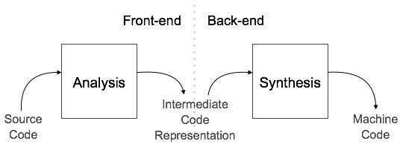

*2. Synthesis phase:* Known as the back-end of the compiler, the synthesis phase generates the target program with the help of intermediate source code representation and symbol table. This phase consists of: ➢ Code Optimization

➢ Intermediate Code Generation

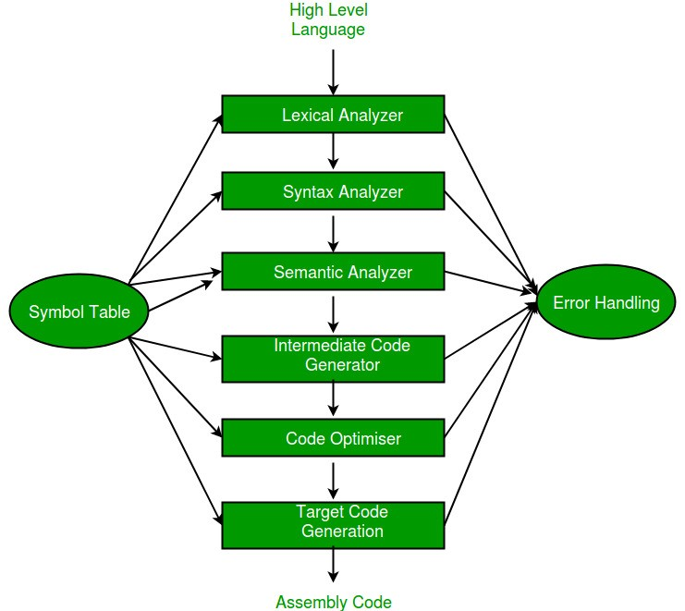

### **Lexical Analysis**

Lexical analysis is the first phase of a compiler. It takes the modified source code from language preprocessors that are written in the form of sentences. The lexical analyzer breaks these syntaxes into a series of tokens, by removing any whitespace or comments in the source code. If the lexical analyzer finds a token invalid, it generates an error. The lexical analyzer works closely with the syntax analyzer. It reads character streams from the source code, checks for legal tokens, and passes the data to the syntax analyzer when it demands.

## Syntax Analysis

Syntax analysis or parsing is the second phase of a compiler. It takes the token produced by lexical analysis as input and generates a parse tree (or syntax tree).

## Semantic Analysis

Semantic analysis is the third phase of a compiler. Semantic analyzer checks whether the parse tree constructed by the syntax analyzer follows the rules of language.

## Intermediate Code Generator

It generates intermediate code, that is a form which can be readily executed by machine. We have many popular intermediate codes. Example – Three address code etc. Intermediate code is converted to machine language using the last two phases which are platform dependent.

Till intermediate code, it is the same for every compiler out there, but after that, it depends on the platform. To build a new compiler we don’t need to build it from scratch. We can take the intermediate code from the already existing compiler and build the last two parts.

## Code Optimizer

It transforms the code so that it consumes fewer resources and produces more speed. The meaning of the code being transformed is not altered. Optimization can be categorized into two types: machine dependent and machine independent.

In our project, we have handled the following constructs:

* Looping construct: while, for, do-while
* Data types: (signed/unsigned) int, float
* Arithmetic and Relational Operators
* Data structure: Arrays
* User defined functions
* Keywords of C language
* Single and multi-line comments
* Identifiers and Constant errors
* Selection statement: (nested) if-else, while

**Question No :02**

**Give a sample input and output for your compiler construction project**

# **7. Input and Output of Mini Compiler**

## 7.1 Lexical Analysis

Test case : **isPrime.c**

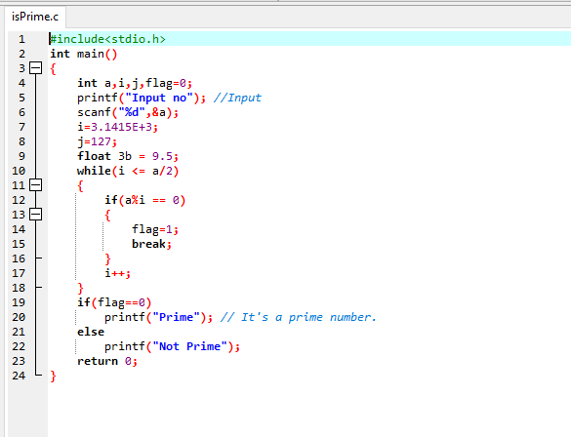

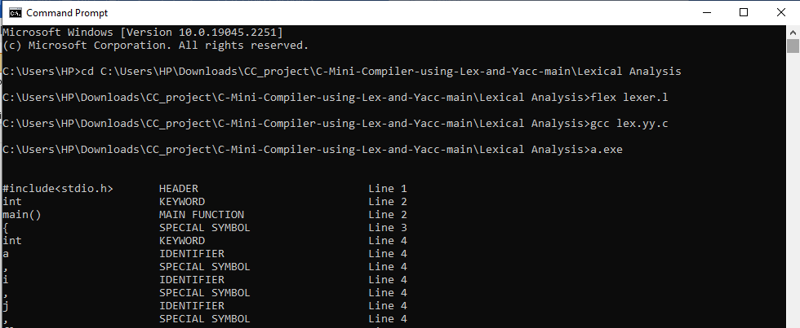

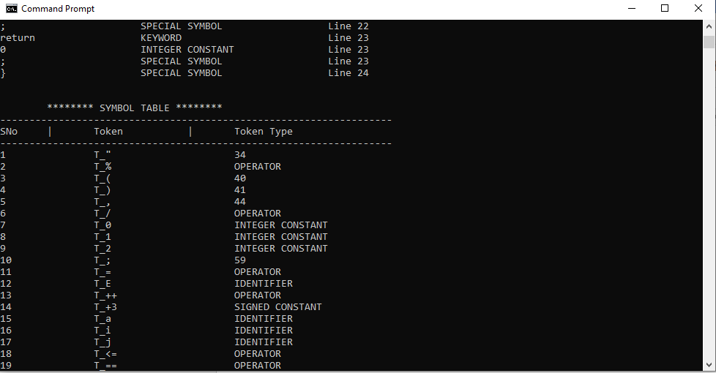

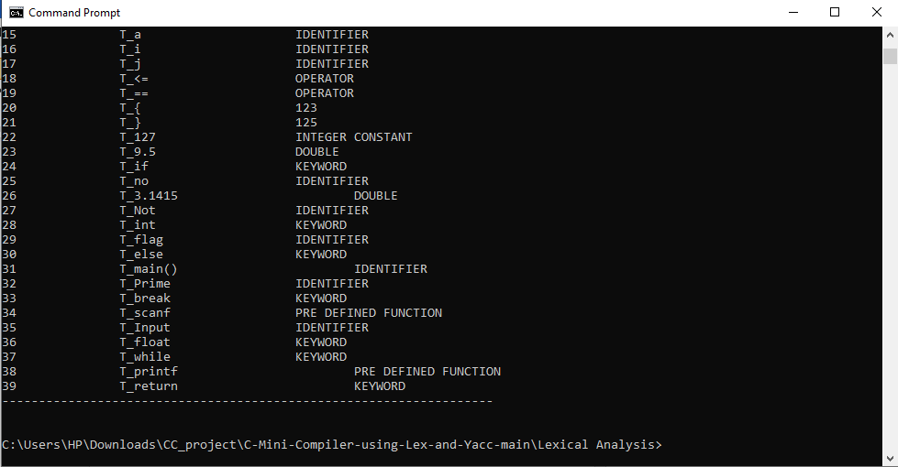

### 7.2 Syntax Analysis

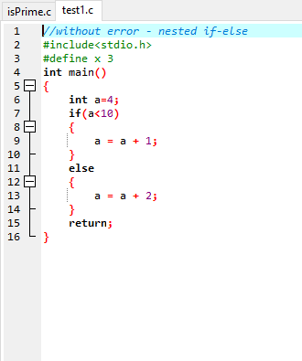 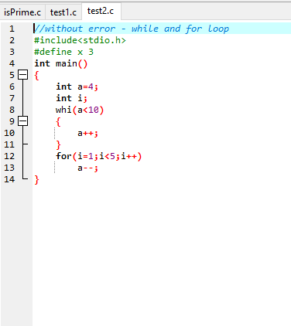

**Output:**

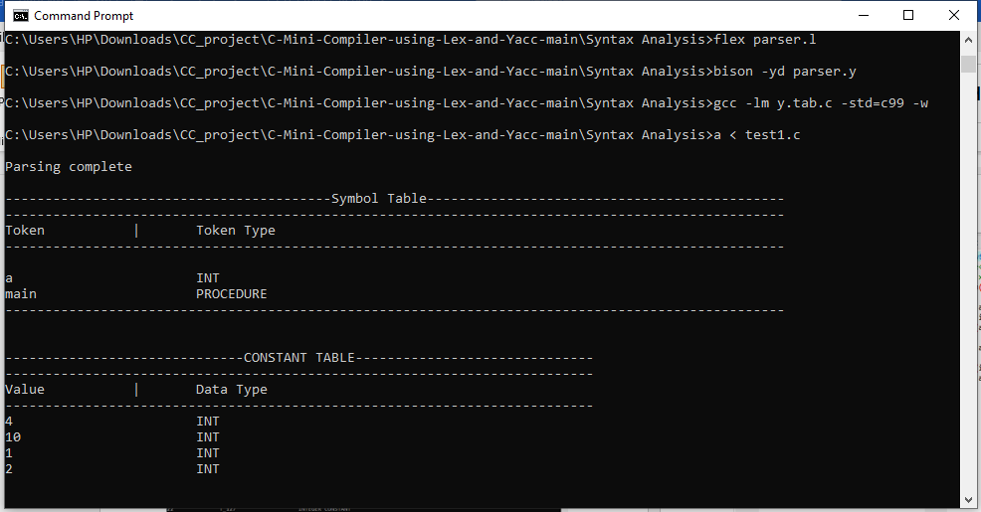

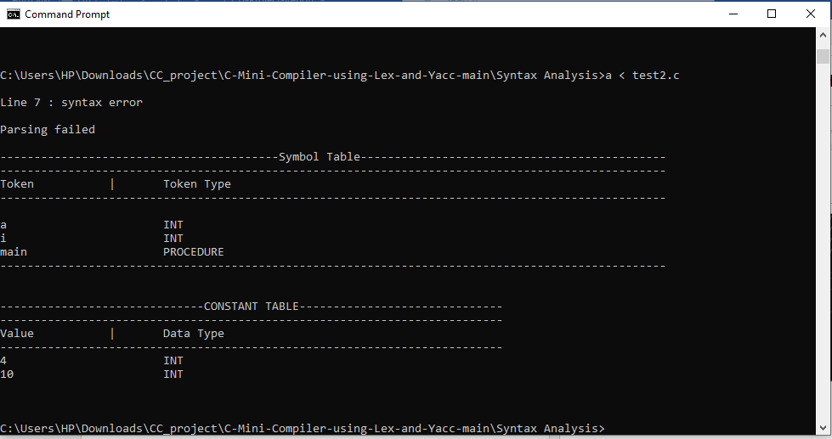

## 7.3 Semantic Analysis

**Input:**

Test case:

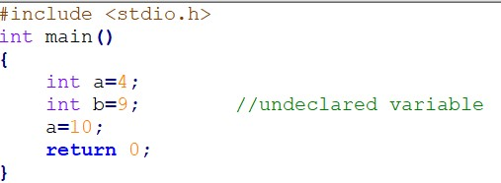

**Output:**

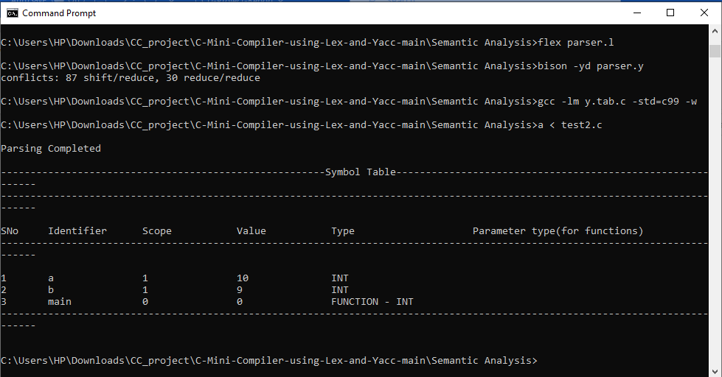

## 7.4 Abstract Syntax Tree

**Input:**

Test Case: input.c

Output :

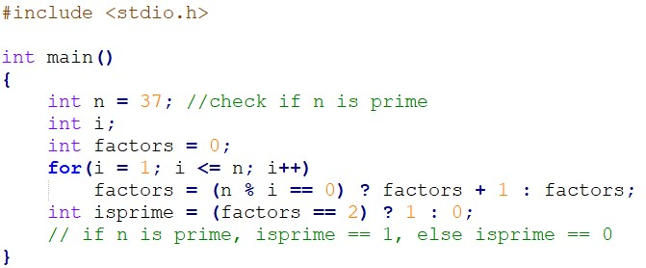

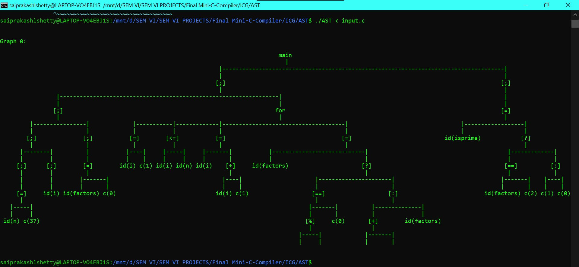

## 7.5 Intermediate Code Generation:

Test Cases:

test1.c :

test2.c :

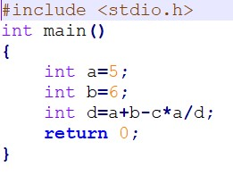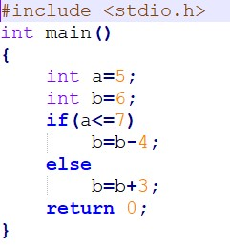

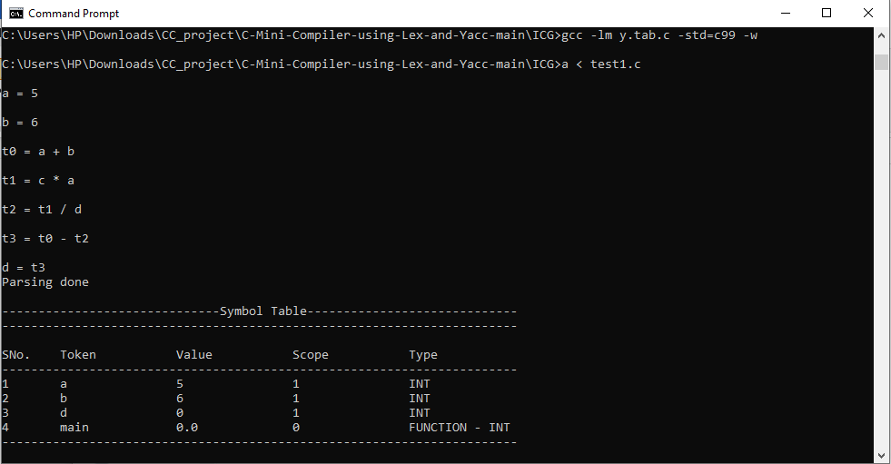

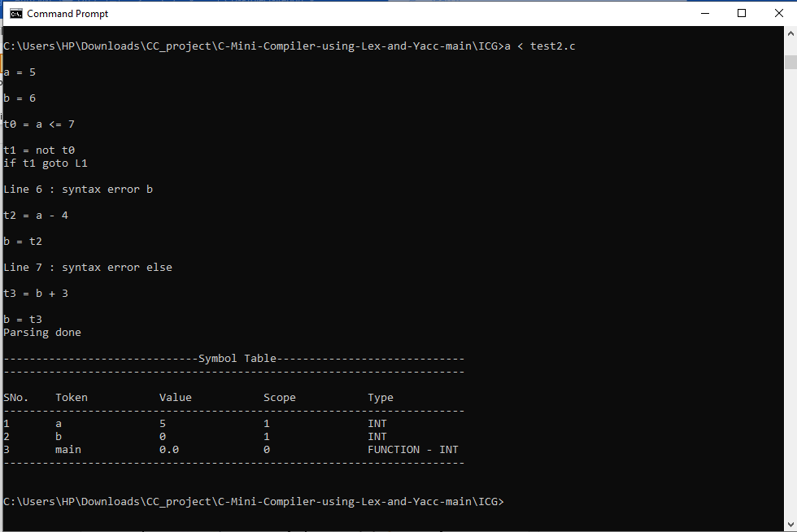

## 7.6 ICG in Quadruple format

**Input:**

Test Case: input.c

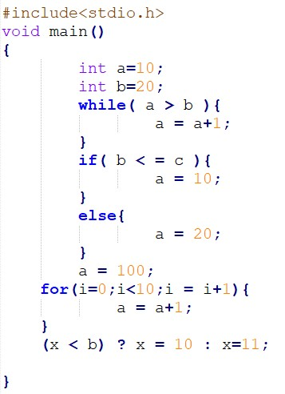

**Output:**

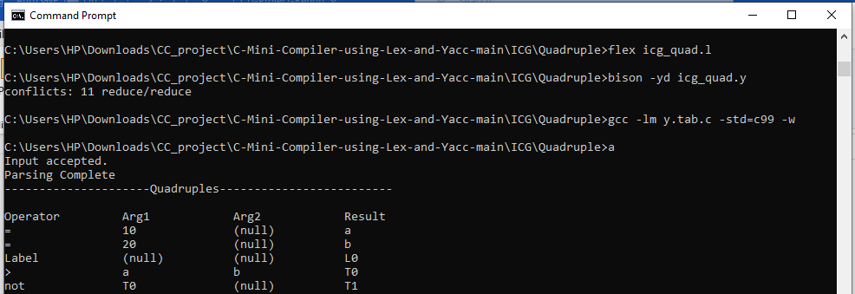

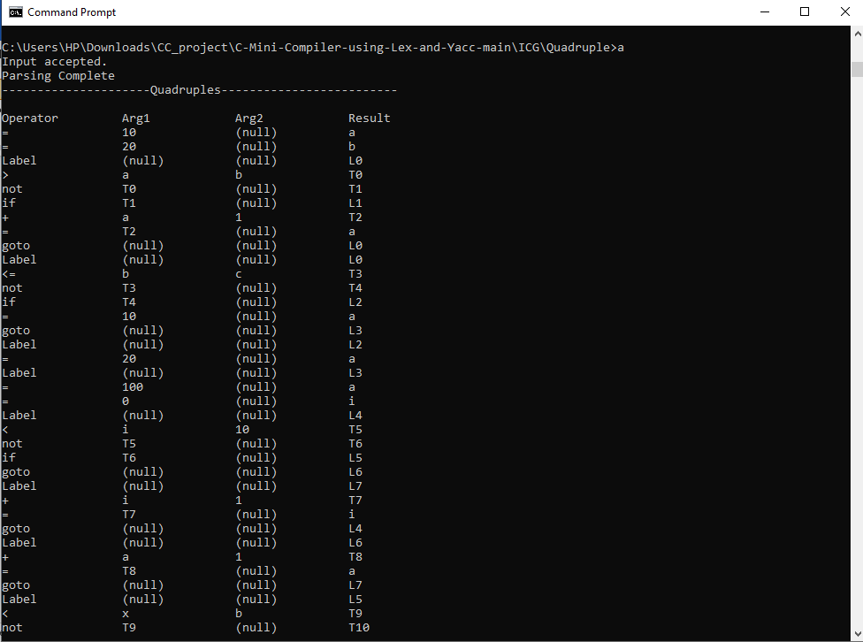

## 7.7 Code Optimization

## Input:

## Test case : output_file.txt

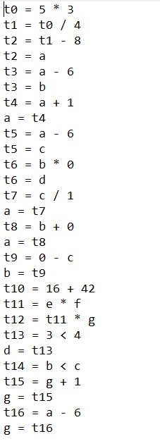

**Output:**

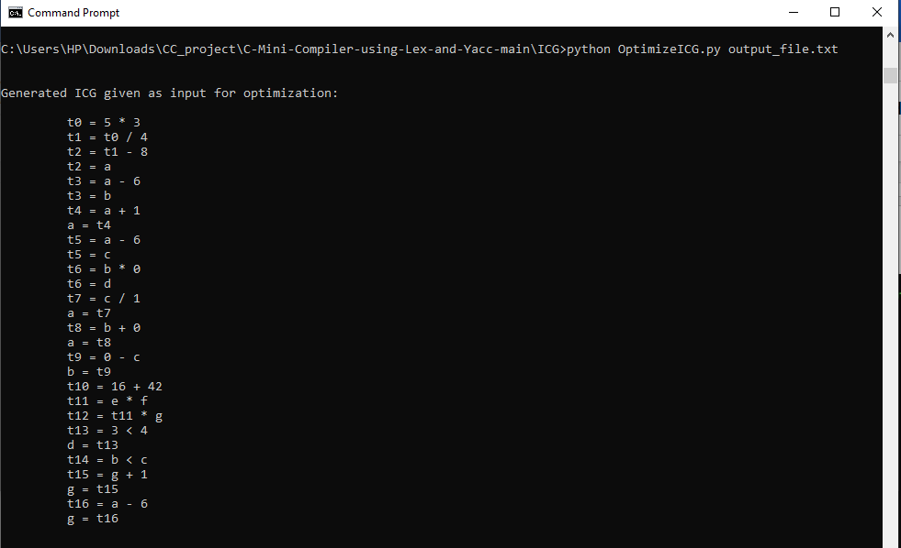

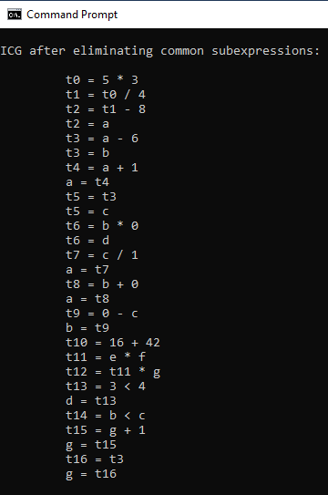 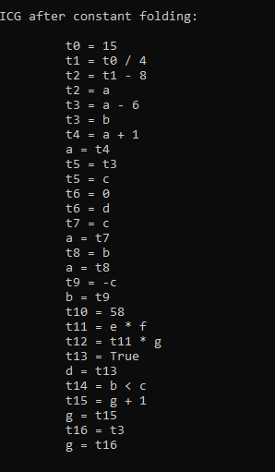

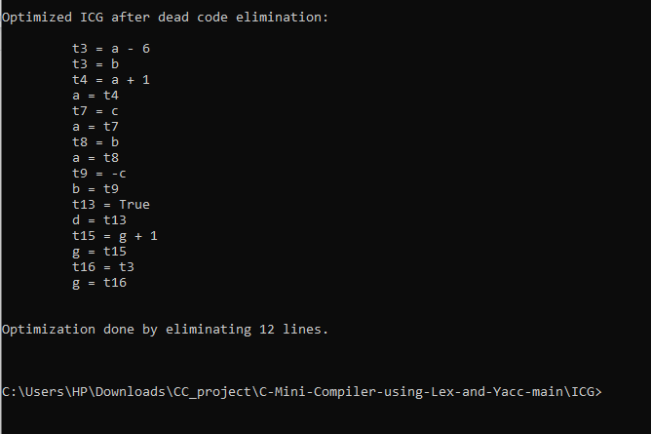

# **CONCLUSION:**

The lexical analyzer, syntax analyzer and the semantic analyzer for a subset of C language, which include selection statements, compound statements, iteration statements (for, while and do-while) and user defined functions are generated. It is important to define unambiguous grammar in the syntax analysis phase.

The semantic analyzer performs type checking, reports various errors such as undeclared variable, type mismatch, errors in function call (number and datatypes of parameters mismatch) and errors in array indexing.

The syntax analyzer for the C language by writing two scripts, one that acts as a lexical analyzer (lexer) and outputs a stream of tokens, and the other one that acts as a parser. The Syntax analyzer generates the various statements and expressions required based on the context free grammar defined. Parse trees for various statements and expressions are generated by the syntax analyzer.

The Intermediate Code Generation phase involves the execution of lex and yacc codes. Once the parsing is complete, if errors are encountered then the errors are displayed along with the line numbers. Along with this, the updated symbol table is displayed.

**Question 3**

**Create and implement RE and DFAs for the form below**

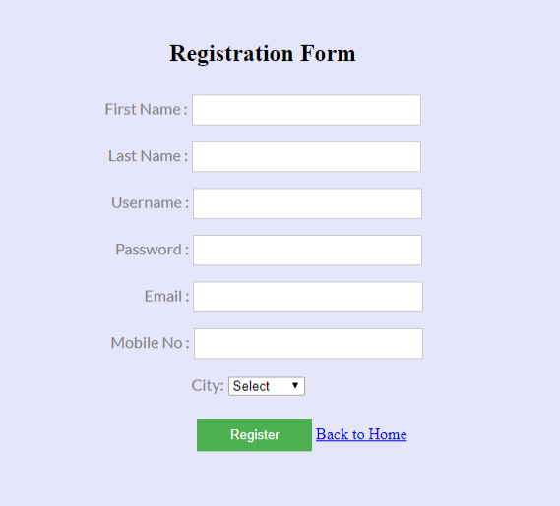

**Code :**

html

<!DOCTYPE html>

<html>

<head>

    <title>Registration Form</title>

    <style>

        body {

            background-color: #E6E6FA;

            font-family: Arial, sans-serif;

        }

        .container {

            width: 300px;

            margin: 0 auto;

            padding-top: 50px;

        }

        form {

            background: #FFF;

            padding: 20px;

            border-radius: 10px;

            box-shadow: 0px 0px 10px 0px #000;

        }

        label, input, select {

            display: block;

            width: 100%;

            margin-bottom: 10px;

        }

        button {

            background-color: green;

            color: white;

            padding: 10px;

            border: none;

            border-radius: 5px;

            cursor: pointer;

        }

        .error {

            color: red;

            font-size: 0.9em;

            margin-top: -10px;

            margin-bottom: 10px;

        }

    </style>

</head>

<body>

    <div class="container">

        <form id="registrationForm">

            <h2>Registration Form</h2>

            <label>First Name: <input type="text" id="firstName" required></label>

            <span class="error" id="firstNameError"></span>

            <label>Last Name: <input type="text" id="lastName" required></label>

            <span class="error" id="lastNameError"></span>

            <label>Username: <input type="text" id="username" required></label>

            <span class="error" id="usernameError"></span>

            <label>Password: <input type="password" id="password" required></label>

            <span class="error" id="passwordError"></span>

            <label>Email: <input type="email" id="email" required></label>

            <span class="error" id="emailError"></span>

            <label>Mobile No: <input type="text" id="mobile" required></label>

            <span class="error" id="mobileError"></span>

            <label>City:

                <select id="city" required>

                    <option value="Select">Select</option>

                    <option value="New York">New York</option>

                    <option value="Los Angeles">Los Angeles</option>

                    <option value="Chicago">Chicago</option>

                </select>

            </label>

            <span class="error" id="cityError"></span>

            <button type="submit">Register</button>

        </form>

        <a href="index.html">Back to Home</a>

    </div>

    <script>

        const form = document.getElementById('registrationForm');

        form.addEventListener('submit', function(event) {

            // Regular Expressions

            const nameRegex = /^[A-Za-z]+$/;

            const usernameRegex = /^[A-Za-z0-9_]{3,16}$/;

            const passwordRegex = /^(?=.*[A-Z])(?=.*[a-z])(?=.*\d)(?=.*[@$!%*?&])[A-Za-z\d@$!%*?&]{8,}$/;

            const emailRegex = /^[a-zA-Z0-9._%+-]+@[a-zA-Z0-9.-]+\.[a-zA-Z]{2,}$/;

            const mobileRegex = /^\d{10}$/;

            const cityRegex = /^(Select|New York|Los Angeles|Chicago)$/;

            // Input Values

            const firstName = document.getElementById('firstName').value;

            const lastName = document.getElementById('lastName').value;

            const username = document.getElementById('username').value;

            const password = document.getElementById('password').value;

            const email = document.getElementById('email').value;

            const mobile = document.getElementById('mobile').value;

            const city = document.getElementById('city').value;

            // Error Messages

            const firstNameError = document.getElementById('firstNameError');

            const lastNameError = document.getElementById('lastNameError');

            const usernameError = document.getElementById('usernameError');

            const passwordError = document.getElementById('passwordError');

            const emailError = document.getElementById('emailError');

            const mobileError = document.getElementById('mobileError');

            const cityError = document.getElementById('cityError');

            // Reset Error Messages

            firstNameError.textContent = '';

            lastNameError.textContent = '';

            usernameError.textContent = '';

            passwordError.textContent = '';

            emailError.textContent = '';

            mobileError.textContent = '';

            cityError.textContent = '';

            // Validation

            let isValid = true;

            if (!nameRegex.test(firstName)) {

                firstNameError.textContent = 'Invalid First Name';

                isValid = false;

            }

            if (!nameRegex.test(lastName)) {

                lastNameError.textContent = 'Invalid Last Name';

                isValid = false;

            }

            if (!usernameRegex.test(username)) {

                usernameError.textContent = 'Invalid Username';

                isValid = false;

            }

            if (!passwordRegex.test(password)) {

                passwordError.textContent = 'Invalid Password';

                isValid = false;

            }

            if (!emailRegex.test(email)) {

                emailError.textContent = 'Invalid Email';

                isValid = false;

            }

            if (!mobileRegex.test(mobile)) {

                mobileError.textContent = 'Invalid Mobile Number';

                isValid = false;

            }

            if (!cityRegex.test(city)) {

                cityError.textContent = 'Invalid City';

                isValid = false;

            }

            if (!isValid) {

                event.preventDefault();

            } else {

                alert('Registration Successful!');

            }

        });

    </script>

</body>

</html>

**Output :**

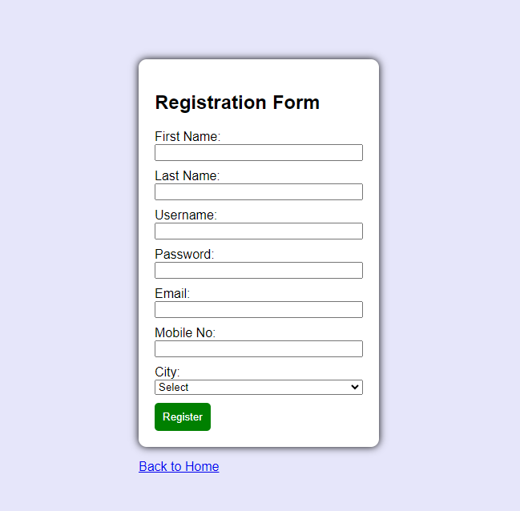

**Question #04**

**Code :**

html

<!DOCTYPE html>

<html>

<head>

    <title>Registration Form with Symbol Table</title>

    <style>

        body {

            background-color: #E6E6FA;

            font-family: Arial, sans-serif;

        }

        .container {

            width: 300px;

            margin: 0 auto;

            padding-top: 50px;

        }

        form {

            background: #FFF;

            padding: 20px;

            border-radius: 10px;

            box-shadow: 0px 0px 10px 0px #000;

        }

        label, input, select {

            display: block;

            width: 100%;

            margin-bottom: 10px;

        }

        button {

            background-color: green;

            color: white;

            padding: 10px;

            border: none;

            border-radius: 5px;

            cursor: pointer;

        }

        .error {

            color: red;

            font-size: 0.9em;

            margin-top: -10px;

            margin-bottom: 10px;

        }

        .symbol-table {

            margin-top: 20px;

            background: #FFF;

            padding: 10px;

            border-radius: 10px;

            box-shadow: 0px 0px 10px 0px #000;

        }

        .symbol-table table {

            width: 100%;

            border-collapse: collapse;

        }

        .symbol-table th, .symbol-table td {

            border: 1px solid #000;

            padding: 5px;

            text-align: left;

        }

    </style>

</head>

<body>

    <div class="container">

        <form id="registrationForm">

            <h2>Registration Form</h2>

            <label>First Name: <input type="text" id="firstName" required></label>

            <span class="error" id="firstNameError"></span>

            <label>Last Name: <input type="text" id="lastName" required></label>

            <span class="error" id="lastNameError"></span>

            <label>Username: <input type="text" id="username" required></label>

            <span class="error" id="usernameError"></span>

            <label>Password: <input type="password" id="password" required></label>

            <span class="error" id="passwordError"></span>

            <label>Email: <input type="email" id="email" required></label>

            <span class="error" id="emailError"></span>

            <label>Mobile No: <input type="text" id="mobile" required></label>

            <span class="error" id="mobileError"></span>

            <label>City:

                <select id="city" required>

                    <option value="Select">Select</option>

                    <option value="New York">New York</option>

                    <option value="Los Angeles">Los Angeles</option>

                    <option value="Chicago">Chicago</option>

                </select>

            </label>

            <span class="error" id="cityError"></span>

            <button type="submit">Register</button>

        </form>

        <a href="index.html">Back to Home</a>

    </div>

    <div class="container symbol-table">

        <h2>Symbol Table</h2>

        <table id="symbolTable">

            <thead>

                <tr>

                    <th>Field Name</th>

                    <th>Type</th>

                    <th>Validation Regex</th>

                </tr>

            </thead>

            <tbody>

                <!-- Symbol table entries will be added here -->

            </tbody>

        </table>

    </div>

    <script>

        const form = document.getElementById('registrationForm');

        const symbolTable = [

            { fieldName: 'firstName', type: 'text', regex: /^[A-Za-z]+$/ },

            { fieldName: 'lastName', type: 'text', regex: /^[A-Za-z]+$/ },

            { fieldName: 'username', type: 'text', regex: /^[A-Za-z0-9_]{3,16}$/ },

            { fieldName: 'password', type: 'password', regex: /^(?=.*[A-Z])(?=.*[a-z])(?=.*\d)(?=.*[@$!%*?&])[A-Za-z\d@$!%*?&]{8,}$/ },

            { fieldName: 'email', type: 'email', regex: /^[a-zA-Z0-9._%+-]+@[a-zA-Z0-9.-]+\.[a-zA-Z]{2,}$/ },

            { fieldName: 'mobile', type: 'text', regex: /^\d{10}$/ },

            { fieldName: 'city', type: 'select', regex: /^(Select|New York|Los Angeles|Chicago)$/ }

        ];

        const populateSymbolTable = () => {

            const tableBody = document.getElementById('symbolTable').querySelector('tbody');

            symbolTable.forEach(entry => {

                const row = document.createElement('tr');

                Object.values(entry).forEach(value => {

                    const cell = document.createElement('td');

                    cell.textContent = value.toString();

                    row.appendChild(cell);

                });

                tableBody.appendChild(row);

            });

        };

        form.addEventListener('submit', function(event) {

            // Regular Expressions

            const nameRegex = /^[A-Za-z]+$/;

            const usernameRegex = /^[A-Za-z0-9_]{3,16}$/;

            const passwordRegex = /^(?=.*[A-Z])(?=.*[a-z])(?=.*\d)(?=.*[@$!%*?&])[A-Za-z\d@$!%*?&]{8,}$/;

            const emailRegex = /^[a-zA-Z0-9._%+-]+@[a-zA-Z0-9.-]+\.[a-zA-Z]{2,}$/;

            const mobileRegex = /^\d{10}$/;

            const cityRegex = /^(Select|New York|Los Angeles|Chicago)$/;

            // Input Values

            const firstName = document.getElementById('firstName').value;

            const lastName = document.getElementById('lastName').value;

            const username = document.getElementById('username').value;

            const password = document.getElementById('password').value;

            const email = document.getElementById('email').value;

            const mobile = document.getElementById('mobile').value;

            const city = document.getElementById('city').value;

            // Error Messages

            const firstNameError = document.getElementById('firstNameError');

            const lastNameError = document.getElementById('lastNameError');

            const usernameError = document.getElementById('usernameError');

            const passwordError = document.getElementById('passwordError');

            const emailError = document.getElementById('emailError');

            const mobileError = document.getElementById('mobileError');

            const cityError = document.getElementById('cityError');

            // Reset Error Messages

            firstNameError.textContent = '';

            lastNameError.textContent = '';

            usernameError.textContent = '';

            passwordError.textContent = '';

            emailError.textContent = '';

            mobileError.textContent = '';

            cityError.textContent = '';

            // Validation

            let isValid = true;

            if (!nameRegex.test(firstName)) {

                firstNameError.textContent = 'Invalid First Name';

                isValid = false;

            }

            if (!nameRegex.test(lastName)) {

                lastNameError.textContent = 'Invalid Last Name';

                isValid = false;

            }

            if (!usernameRegex.test(username)) {

                usernameError.textContent = 'Invalid Username';

                isValid = false;

            }

            if (!passwordRegex.test(password)) {

                passwordError.textContent = 'Invalid Password';

                isValid = false;

            }

            if (!emailRegex.test(email)) {

                emailError.textContent = 'Invalid Email';

                isValid = false;

            }

            if (!mobileRegex.test(mobile)) {

                mobileError.textContent = 'Invalid Mobile Number';

                isValid = false;

            }

            if (!cityRegex.test(city)) {

                cityError.textContent = 'Invalid City';

                isValid = false;

            }

            if (!isValid) {

                event.preventDefault();

            } else {

                alert('Registration Successful!');

            }

        });

        // Populate the symbol table on page load

        populateSymbolTable();

    </script>

</body>

</html>

**Output :**

